August 3rd, 2008
Hi
Well, first of all, its ‘Happy Birthday’ to Leonie for tomorrow. Take your pick of birthday cards! (Actually, I have used these cars before but they are quite good.)

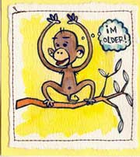
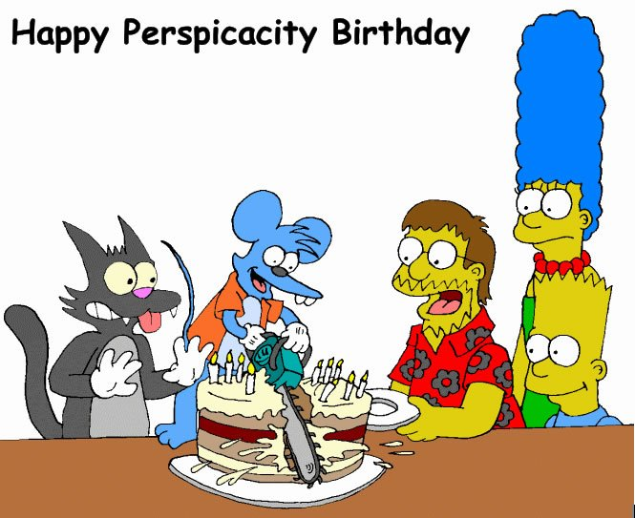

Finished reading the book of short stories by Arthur C Clarke. Very gripping – had finished the whole book in just over two days. I then replaced it with another written by Clarke in collaboration with another person. Nowhere near as good. It seems to me to be basically a short story that has been excessively padded with lots of side tracks and detail to fill about 500 pages, a lot of which is boring. In collaborating, it seems that Clarke has done the basic work and left the main writing to the other guy. I just skimmed many chunks to get to the main parts that are good.
Hong Kong, like China, is awaiting the start of the Olympic Games next Friday. As you know, the equestrian events are being held here. Apparently, the facilities provided for athletes and horses are very good, according to the riders. Horses even get stables air-conditioned to 23⁰C as well as water spray showers at the competition sites (Shatin racecourse and the Beas River riding club at Fanling). Security will be tight. It has been announced that, if needed, the PLA will be brought in! Also, the event organisers are getting strict about dress code. Spectators are not allowed to wear anything that bears any advertising logo. (This is rather difficult as so much of what you buy contains logos, e.g. T-shirts and especially footwear. The same rules apply to riders and sponsors.) Overall, I am not terribly worked-up over the games though I will probably watch the opening ceremony which will be at 8 pm on 8 – 8 -08. I guess you know why the ‘8’s are chosen.

Air pollution levels in parts of HK reached their highest ever this past week. In Tap Mun, the reading reached 202.
On Tuesday, I was woken at 7:30 am with a call from the front desk to tell me that the unit was on fire!!! I looked around and could not see a fire but saw that the warning lights on the alarm were on, suggesting a false alarm. The alarm was changed a few minutes later. Visited the dermatology clinic the same day. Next month is my regular hospital visit so the plan is to have plastic surgery for the small and very pale patch on my nose that has not responded to liquid nitrogen treatment.

Mid-week, I got a surprise telephone call from Dell, who were offering to help with the computer problem!! Surprising, though I have not heard from them again yet. I read in TIME magazine that some dissatisfied customer in the US did a lot of PR damage to Dell via the Internet for lousy, non-existent service.
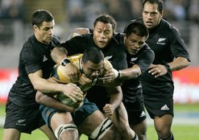
Yesterday, I watched the second ABs v Wallabies test on TV. I, like many others, thought the ABs would be rolled over as they were last week. How wrong everybody was. They thrashed Australia 39-10 in an extremely impressive performance dominating the game in all aspects of play where last week they were outplayed and, as one commentator on Planet Rugby said were just playing like a bunch of “decapitated chickens.” Did I mention that the final Bledisloe Cup game (competition between just NZ and Australia) will be played in HK on November 1st? Tickets are already sold out. This will be the first time Rugby at such a level has been held in HK. Following that, I think, the ABs go on a European tour; read that the Wales v NZ game in Cardiff is also already sold out.
That seems to be it for now.

Cheers

